**1. Assign the value 7 to the variable guess_me. Then, write the conditional tests (if, else, and elif) to print the string 'too low' if guess_me is less than 7, 'too high' if greater than 7, and 'just right' if equal to 7.**

**Ans:**

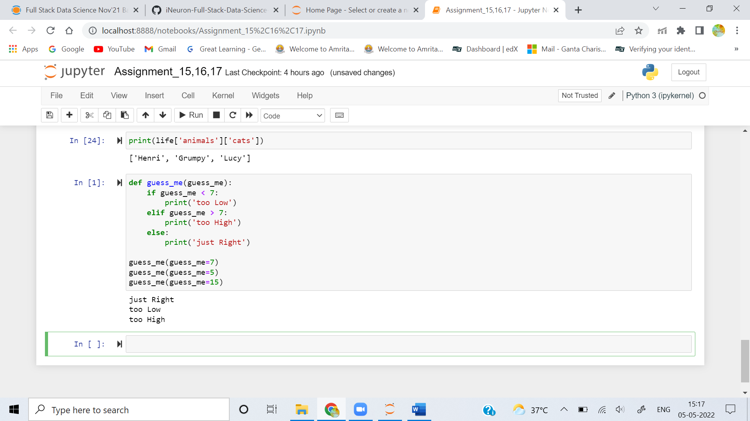

**2. Assign the value 7 to the variable guess_me and the value 1 to the variable start. Write a while loop that compares start with guess_me. Print too low if start is less than guess me. If start equals guess_me, print 'found it!' and exit the loop. If start is greater than guess_me, print 'oops' and exit the loop. Increment start at the end of the loop.**

**Ans:** 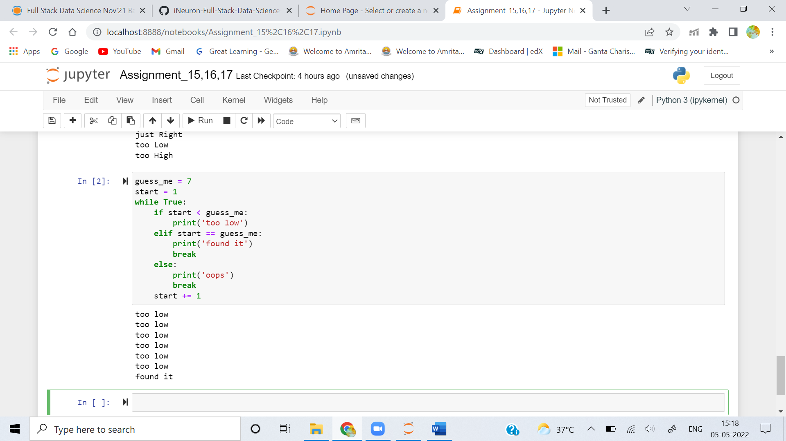

**3. Print the following values of the list [3, 2, 1, 0] using a for loop.**

**Ans:** 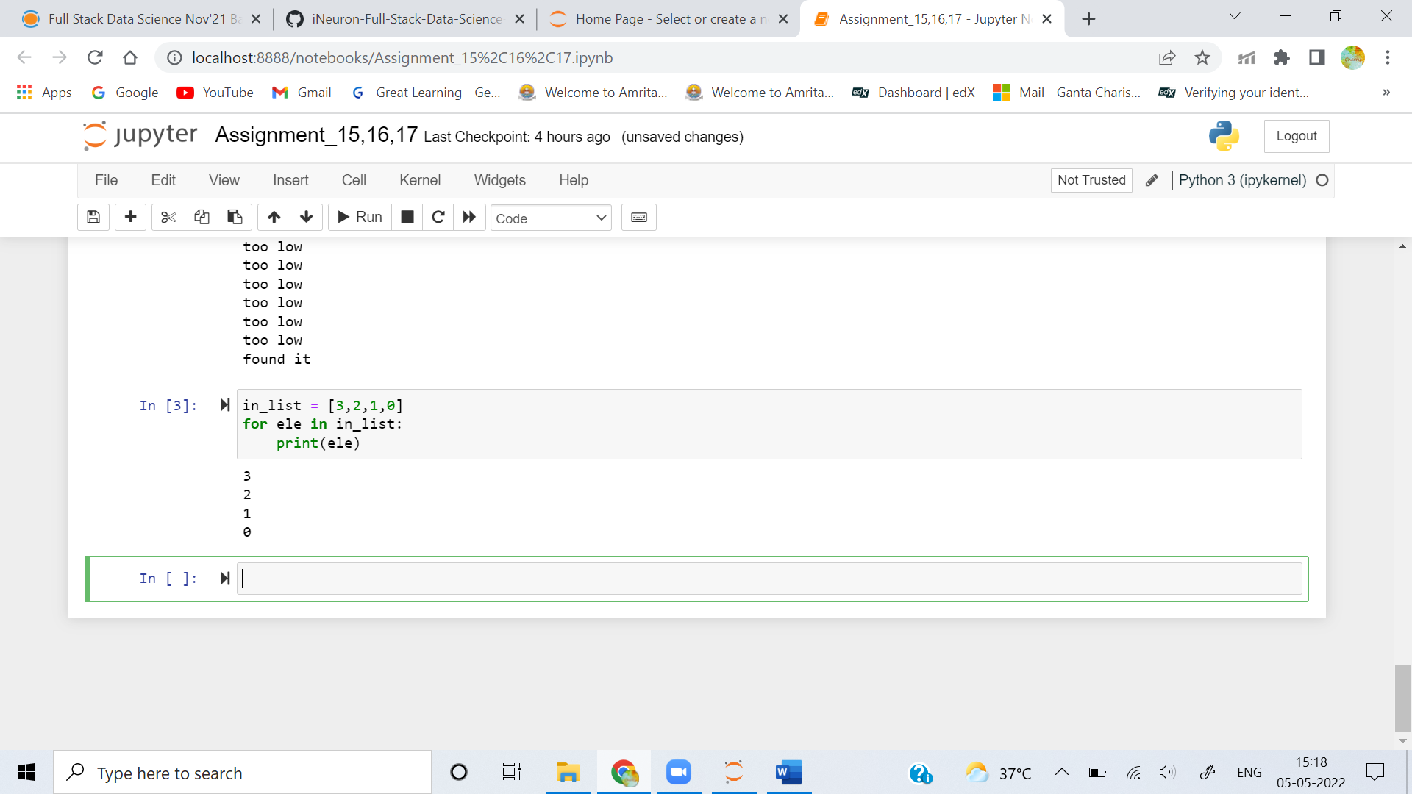

**4. Use a list comprehension to make a list of the even numbers in range(10)**

**Ans:** 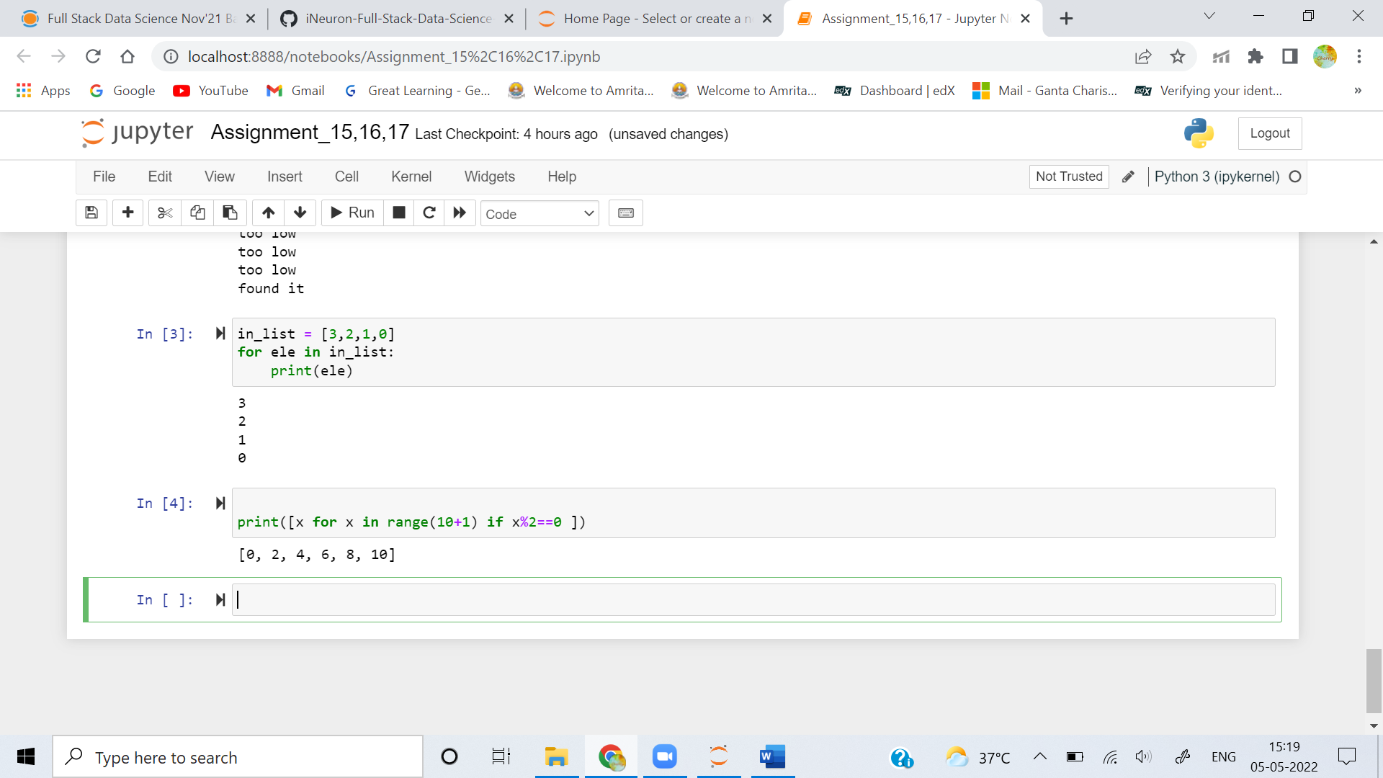

**5. Use a dictionary comprehension to create the dictionary squares. Use range(10) to return the keys, and use the square of each key as its value.**

**Ans:** 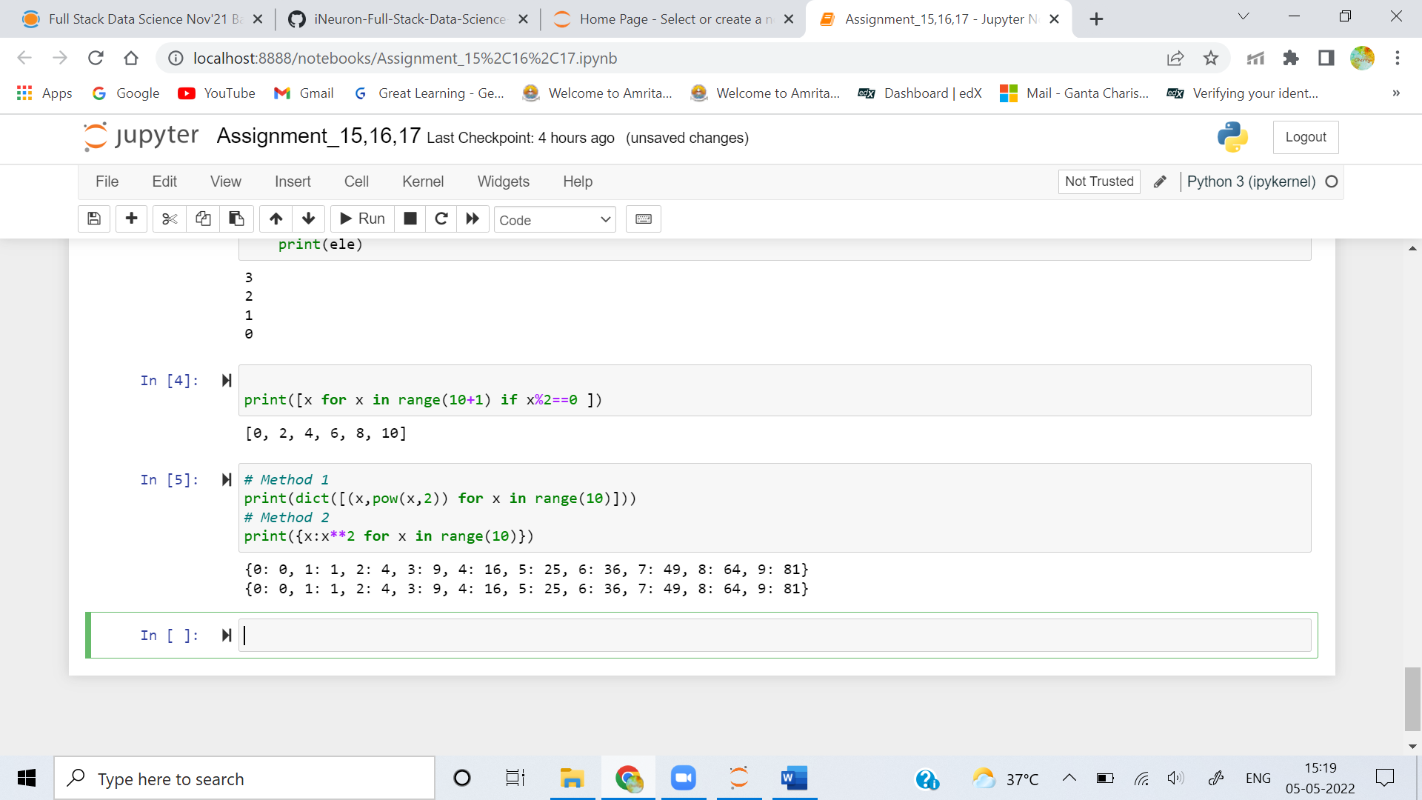

**6. Construct the set odd from the odd numbers in the range using a set comprehension (10).**

**Ans:** 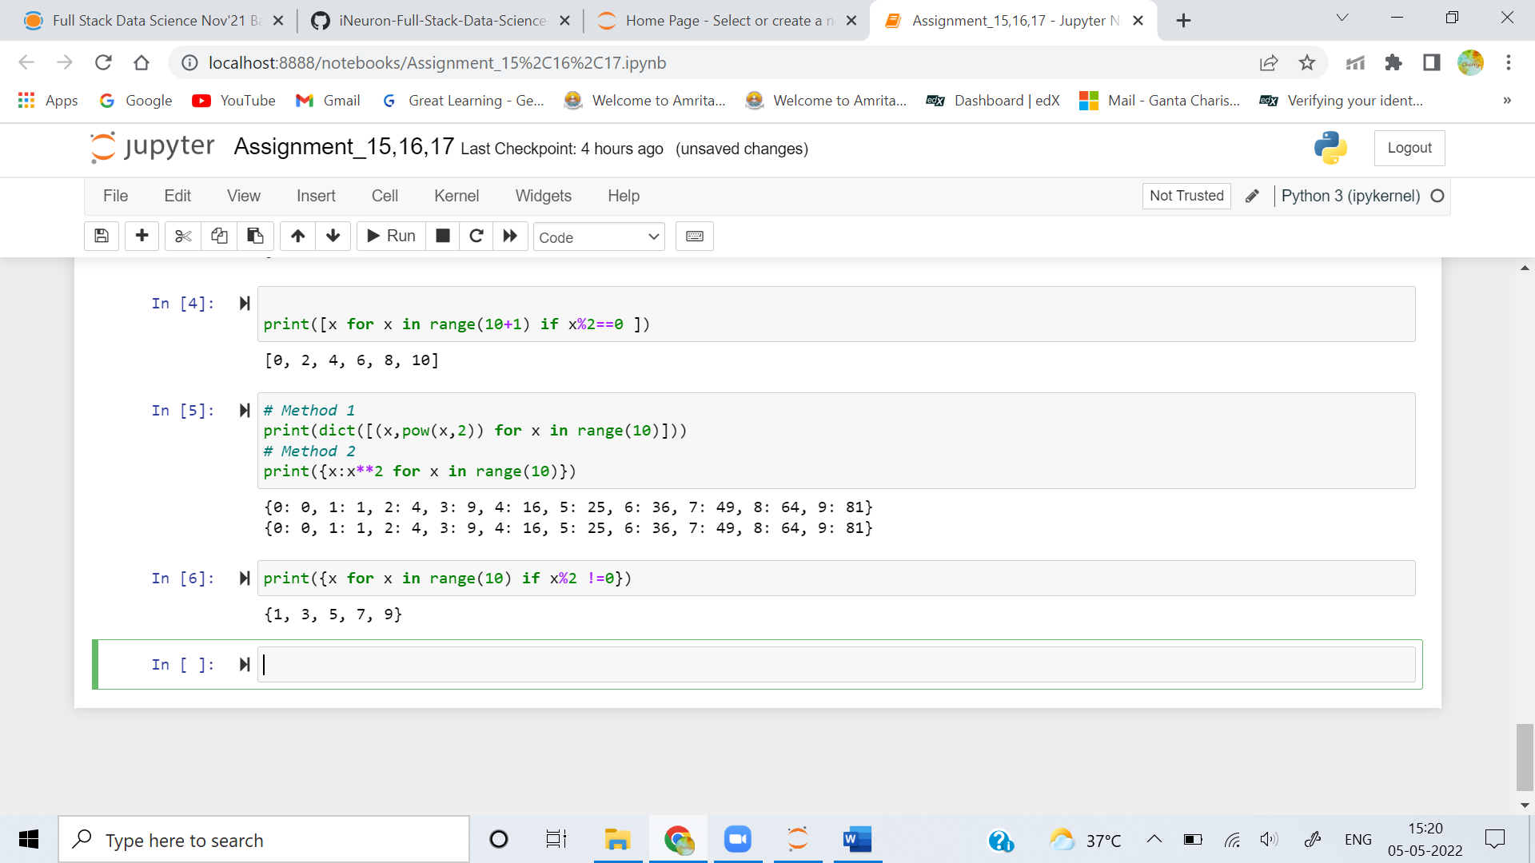

**7. Use a generator comprehension to return the string 'Got ' and a number for the numbers in range(10). Iterate through this by using a for loop.**

**Ans:** 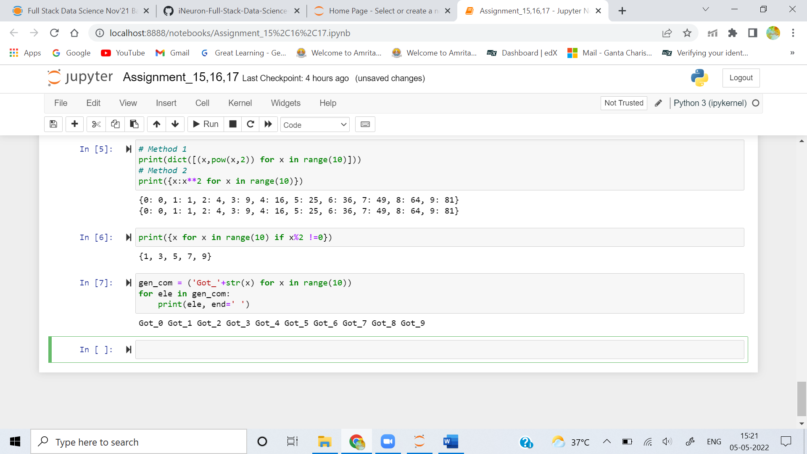

**8. Define a function called good that returns the list ['Harry', 'Ron', 'Hermione'].**

**Ans:** 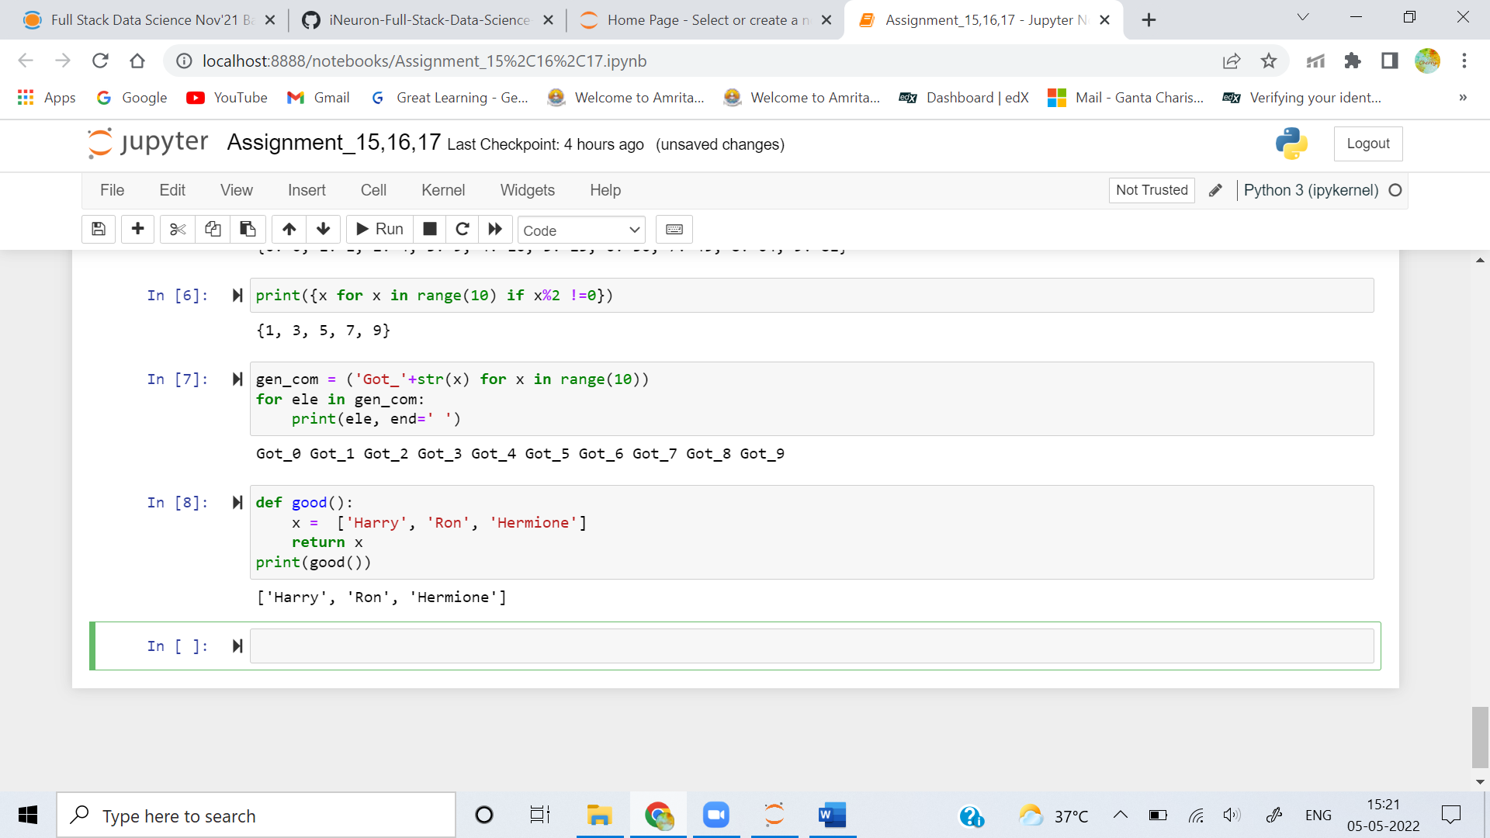

**9. Define a generator function called get_odds that returns the odd numbers from range(10). Use a for loop to find and print the third value returned.**

**Ans:** 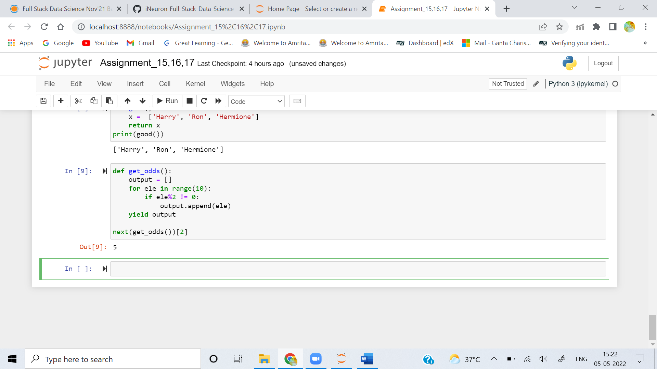

**10. Define an exception called OopsException. Raise this exception to see what happens. Then write the code to catch this exception and print 'Caught an oops'.**

**Ans:** 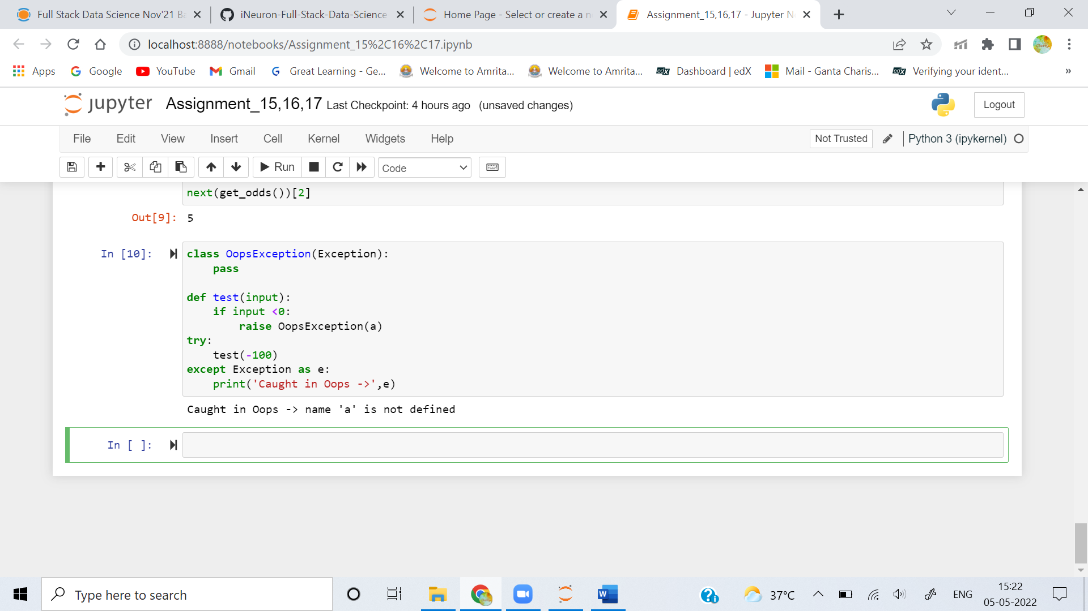

**11. Use zip() to make a dictionary called movies that pairs these lists: titles = ['Creature of Habit', 'Crewel Fate'] and plots = ['A nun turns into a monster', 'A haunted yarn shop'].**

**Ans:**

